Week 3 Summary

This week, I finished the x direction movement of the ball which was supposed to bounce back and forth between the canyon walls. I also finished the logic of the platform movement, which together finishes 20% of the total work.. Finally, I wrote some unit tests that were supposed to test out the x direction movement of the ball.

When I was designing the x Direction movement of the ball, the first case that came up to my mind divide the logic into three parts: when the x coordinate is between 0 and 128, when the x coordinate is between over 128 (hits the right wall, and it should bounce back), and finally the situation where the ball hit the left wall once it bounce back. The first part was easy, I simply added the displacement. The second part is a little tricky, first I thought I just need to minus the excess part from 128 to get the coordinates. But then I think of another situation. Once the ball touches the wall, it continues to go back but the coordinate is less than 128 in this case. So I set up another parameter which should be in the bound between 128 - 2\*128. In this case, once the temporary parameter exceeds 2\*128, it means that the ball touches the left wall, and I can reset every position back to zero.

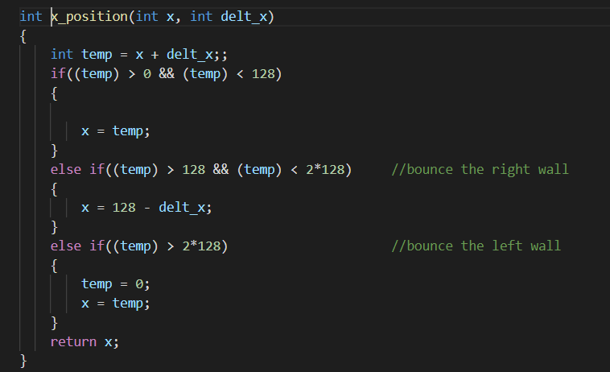

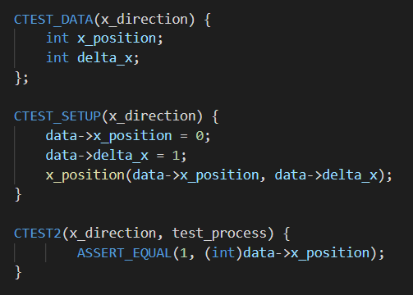

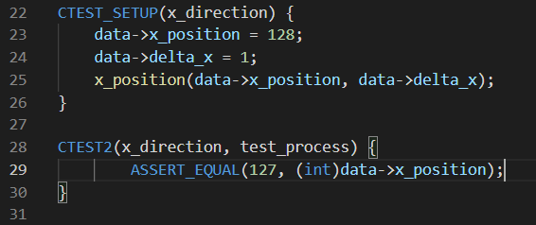

I have run the unit tests for the x direction and y direction of the ball. The x direction is reasonable but y direction has some error due to the unfinished work in y direction. The above two images are two examples of the unit test. For instance, if the x position of the ball is currently zero and the change in position is 1, then by default its location should be in the range between 0 - 128, so in order to get the new position, we simply add the delta x to the original x and the new location should be 1. Another example would be at location 128. This means that the ball hits the rightmost wall and cannot move any more to the right. So if our delta x is still 1, then the ball will bounce back from the wall and should end up in x coordinate 127.

Completed this week:

Half of the physics task, half of the platform task

Not completed:

Remaining half of the physics task and platform task, LED and LCD task.